Wire Frame
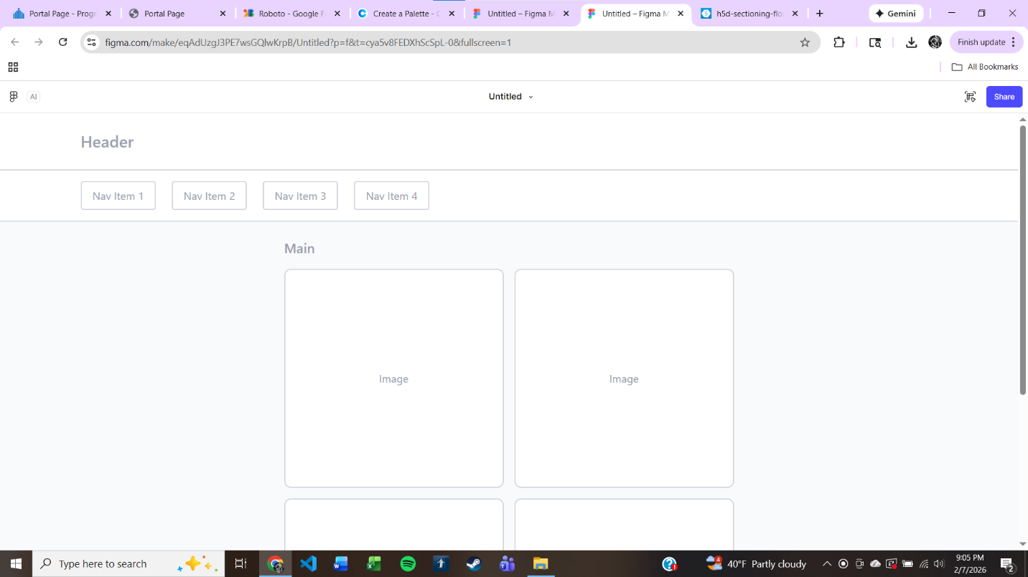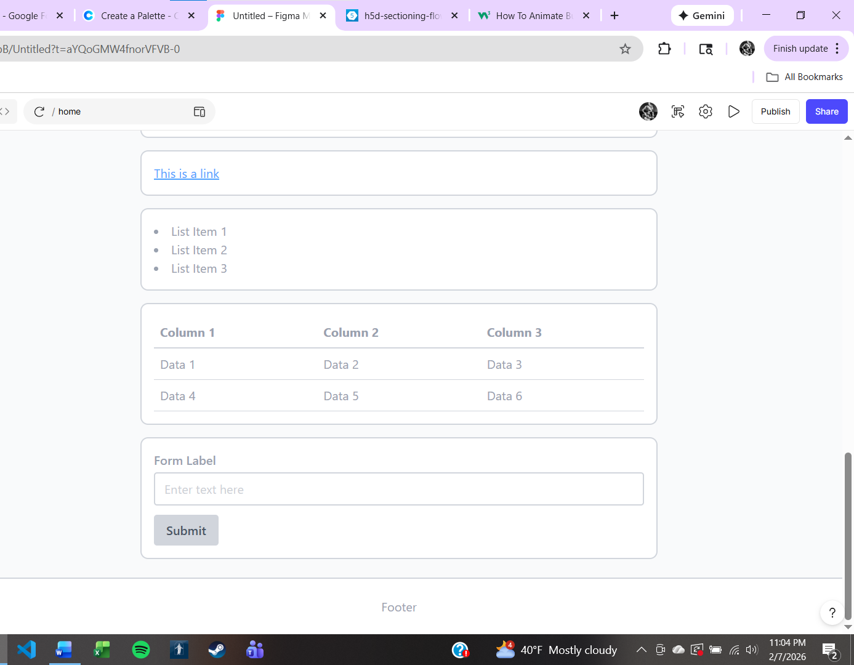

Logo


Color Scheme
542344
BFD1E5
EBF5EE
D8BFAA
808080

Fonts
Roboto
Linotype Didot
American Typewriter

